SACRED HEART PARISH

Sacred Heart Parish Founded 1814, The First Catholic Parish in the STate of New Jersey

Sacred Heart Church, 343 South broad Street, Trenton, New Jersey 08608

Holy Cross Church, 233 Adeline Street, Trenton, New Jersey 08611

ALL ARE WELCOME

Whatever your present status in the Catholic Church, whatever your current family or marital situation,

Whatever your past or present religious affiliation, whatever your personal history, age, background, or

race, whatever your own self-image or esteem, you are invited, welcomed, accepted, loved and

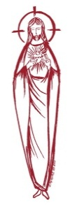
respected at the Parish of the Sacred Heart.

PASTOR

Rev. Msgr. Dennis A. Apoldite
frdennis@trentonsacredheart.org
PAROCHIAL VICAR
Rev. Charles Muorah
Felician Residence for Clergy
233 Adeline Street, Trenton, New Jersey 08611
609-393-4826 ext. 108 for Fr Charles
DEACON
Dr. Christian Nnajiofor

Business ADMINISTRATOR
ADMINISTRATIVE ASSISTANT
John DeSantis: secretary@trentonsacredheart.org
Administrator of religious education
Mary Tovar: reled@trentonsacredheart.org
COORDINATORS OF SACRED MUSIC
Natalie Megules ~ 609-575-6484
Rupert Peters ~ Gospel Mass 609-442-7871
MAINTENANCE DEPARTMENT
Frank Rios
Trustees
Jack Breuer and Ellieen Ancrum Ingbritsen,

OFFICE HOURS

9:00am – 4:00pm Monday – Friday

SACRED HEART PARISH OFFICE

343 South Broad Street, Trenton, NJ 08608

Phone: (609) 393-2801 ~ Fax: (609) 989-8997

WEB PAGE:

www.trentonsacredheart.org

CEMETERY RECORDS
Contact The Office of Catholic Cemeteries at 609-394-2017 or DirectorofCemeteries@DioceseofTrenton.org

SACRAMENTAL RECORDS
Sacred Heart Church, Saint John’s Church, Saint Francis Church, Saints Peter and Paul Church, Saint Stanislaus Church, Holy Cross Church, Blessed Sacrament Church, Our Lady of Divine Shepherd Church, Blessed Sacrament/Our Lady of Divine Shepherd Parish and Divine Mercy Parish.

Liturgy Schedule

Sacred Heart CHURCH
Monday, Tuesday, Wednesday and Friday
12:10 Noon
Saturday Evening 5:15 PM
Sunday Morning 9:00 and 11:15 AM
HOLY CROSS CHURCH
Monday, Thursday and Friday 8:00 AM
Saturday Evening 4:00 PM
Sunday Morning 10:00 AM Gospel
12:00 Noon Polish
For each Holy Day please reference the bulletin

SACRAMENTS
BAPTISM
Please call the Parish Office at least one month in advance.

RECONCILIATION

Every First Friday following the 12:10PM Mass SHC

Saturday afternoon ~ 4:30 to 5:00 PM SHC

Every Saturday from 3:30 to 3:50 PM HCC

Every Sunday 9:30 to 9:50AM HCC

and by appointment.
EUCHARISTIC ADORATION
First Saturday of the Month 2:30 to 3:30 pm
in Holy Cross Church
MARRIAGE
Please call the Parish Priest at least one year in advance to set up initial meeting and to confirm a wedding
date and time.
ANOINTING OF THE SICK
Please call the Priests any time 609-393-2801.
COMMUNION TO THE HOMEBOUND
Call the Parish Office to schedule home visit.
CONSIDERING PRIESTHOOD?
Email: Vocations@DioceseofTrenton.org

HOLY FAMILY OF JESUS
December 31, 2023

MASS INTENTIONS
Saturday, December 30
4:00 pm HCC ~ Eileen Kostrzewa
5:15 pm SHC ~ Nancy Koerwer
Sunday, December 31
10:00 SH ~ For the People of the Parish
10:00 HCC ~ For Thanksgiving
12:00 HCC Polish ~ Ks. Kanonik Jan Majka
Sunday, December 31 ~ New Year’s Eve Masses
4:00pm ~ For the People of the Parish
5:15pm SHC ~ For the People of the Parish
Monday, January 1 ~ New Year’s Day
10:00 SH ~ For the People of the Parish
10:00 HCC ~ For the People of the Parish
12:00 HCC Polish~ For the People of the Parish
Tuesday, January 2
12:10 pm SHC ~ No Mass
Wednesday, January 3
12:10 pm SHC ~ Vita Family
Thursday, January 4
8:00 am HCC ~ Philomena and William Cracker
Friday, January 5
8:00 am HCC ~ Stephen DeAngelo
12:10 pm SHC ~ Izzy Tagliaferri
Saturday, January 6
4:00 pm HCC ~ Jean Birndorf
5:15 pm SHC ~ Ken and Lucille Fisher
Sunday, January 7
9:00 SH ~ Joan Goerig Pastor & Altar Rosary Society
10:00 HCC ~ For the People of the Parish
11:15 SH ~ William Davis
12:00 HCC Polish ~ Edward Ozga, Danuta Karcz, and
Maria Kubas

READINGS FOR THE WEEK
The Holy Family of Jesus, Mary & Joseph
Sunday Gn 15:1-6, Heb 11:8-19; Lk 2:22-40
Monday Nm 6:22-27; Gal 4:4-7; Lk 2:16-21
Tuesday 1 Jn 2:22-28; Jn 1:19-28
Wednesday 1 Jn 2:29-3:61; Jn 1:29-34
Thursday 1 Jn 3:7-10; Jn 1:35-42
First Friday 1 Jn 4:11-21; Jn 1:43-51
Saturday 1 Jn 5:5-13; Mk 1:7-11 or Lk 3:33-38
OUR SICK LIST
Stanley Sniadach, Kristen Topley, Mary Sokolowski, Rocco, Lorraine Wargo, Robert Paci, Mrs. Loatman, David Carver, Jennifer Lyons, Grace Profy, Steve Jurczynski, Cornell Hess, Ruby Covington, Judith Santigo, Ching Kukis, Dan Breese Jr, Brenna Kennedy-Moore, Dawn Chia, Mark Friedman, Alexander A. Ladnyk, Kelly Nitti, Lauren Clayton, Joseph Edralin, Margie Tiongson, Kevin, Vincent Cooper, Jr., Gail Ladnyk, Leo Genovesi, Sloane Donnelly, Richard Buckley, Tony Ragolia, Barbara Burrows, Charles Burrows, Dorothy Amoroso, Maryann Sullivan, Regina Friedman, Stanley Winowicz, Greg Schafer, Jack Hardiman, Amy Birk, Julia Grazioli, Matt Tydryszewski.
OUR DECEASED
Johnn Solano, John Convenio, Robin Haynes, and our friends at South Village, Riverside Nursing and Rehabilitation Center, Mill House and Waters Edge.

MINISTRY SCHEDULE
Saturday, December 30
4:00pm HCC ~ Fr Charles L. R. Micharski Em. C. Benitez
5:15pm Msgr. Dennis L. L. Bellina, Em. W. Lewis & M. Salamandra
Sunday, December 31
10:00 SHC ~ Msgr. Dennis L. K. Valentino Em. H. & M. Figueroa
10:00 HCC ~ Fr. Charles L. F. Kollie Em. D. Ezeuka
12:00 HCC Polish ~ Fr Marian Ewa, Mieciu

Saturday, January 6
4:00pm HCC ~ Fr Charles L. V. Zielinski Em. L. Bliznawiczus
5:15pm SHC ~ Msgr. Dennis L. K Willever Em. A. Solack & B. DuMont
Sunday, January 7
9:00 SHC ~ Msgr. Dennis L. E. Wengryn Em. R.&K. Figueroa
10:00 HCC ~ Fr. Charles L. O. Nnadi Em. Q. Hilton
11:15 SHC ~ Msgr Dennis L. F. Zielinski Em. J. Diaz & S. Jurczynski
12:00 HCC Polish ~ TBD

2023 ANNUAL CATHOLIC APPEAL UPDATE
Goal: $33,000.00
Pledged: $46,627.00 (141% of Goal)

WEEKLY COLLECTION
Last weekend’s will be announced next weekend

PROMISE TO PROTECT
The Diocese of Trenton is committed to the norms of the U.S. Bishop’s Charter for the Protection of Children and Young People in regard to the reporting and investigation of sexual abuse allegations involving minors. If you have been sexually abused as a minor by anyone representing the Catholic Church, you can report that abuse through the diocesan Hotline: 1-888-296-2965 or abuseline@dioceseoftrenton.org. Allegations are reported to the appropriate law enforcement agencies.
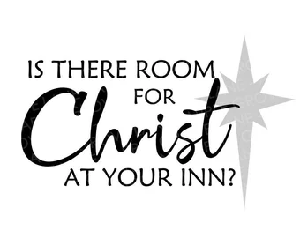

NEW YEAR SCHEDULE
SACRED HEART CHURCH
Saturday, December 30 5:15 PM Vigil Mass
Sunday, December 31 10:00 AM
Feast of Mary, Mother of God ~
NEW YEAR’S EVE
Sunday, December 31 5:15 PM
Monday, January 1 ~ NEW YEAR’S DAY 10:00 AM

HOLY CROSS CHURCH
Saturday, December 30 4:00 PM Vigil Mass
Sunday, December 31
10:00 AM and 12:00 Noon
Feast of Mary, Mother of God
Sunday, Dec. 31 NEW YEAR’S EVE 4:00 PM
Monday, January 1 ~ NEW YEAR’S DAY
10:00 AM Gospel Mass
12:00 Noon Polish Mass

BLESSING OF HOMES
The Blessing of Homes will take place this year during the month of January. The Blessing includes a prayer that God will protect your family during the coming year. Your home will sprinkled with holy water and the initials of the Three Kings who visited and worshipped the Infant Jesus in Bethlehem are written above the lintel of the main door with blessed chalk (Caspar, Melchior, and Balthasar). If you are a registered parishioner and wish to have your home blessed, please complete the form below and return it in the collection basket or drop it off at the Parish Office.

Name __________________________________________
Address___________________________City________
Cell or phone number __________________

SWEAT SOCK DRIVE
It’s that time of year when we need to think about the street people in our area who are in need of clean sweat socks. On the weekend of January 23rd and 24th we ask you to bring to the altar rail sweat socks for the needy. We ask that you do not bring ankle socks. They will be distributed to the street people of Trenton. Thank you.

VOLUNTEER PARTY
The “Little Christmas” Volunteer Appreciation Party, will be held Friday evening, January 5th from 6:00 - 9:00 pm. We will begin with a prayer service at 6:00 pm in Sacred Heart Church followed by light refreshments in Msgr. Toomey Hall. All those who volunteer are invited. Please R.S.V.P. by December 28th by calling the office at 609-393-2801 or by filling out the form below and place in the collection basket. Thank you.
VOLUNTEER PARTY
Name _______________________________
Number attending______________________
Cell or phone number __________________

CONTRIBUTION STATEMENTS
Those interested in receiving a statement documenting contributions made in 2023, please fill out the bottom portion of this notice and return it to the parish office in the collection basket or to secretary@trentonsacredheart.org. A copy of your contribution statement will be mailed to you by the end of the month. If there are discrepancies please be sure to notify us and we will make the adjustments. It would help us if you filled in the amount donated.
Envelop # _________________________________________
Amount Donated _________________________________
Name _____________________________________________
Address___________________________________________
___________________________________________________

ALTAR ROSARY SOCIETY
All rosarians, future rosarians, people of our parish are warmly welcomed to join us on Sunday, January 7th, 9:00am Mass at Sacred Heart Church. The Rosary will be prayed before Mass. Following Mass, a meeting will take place at Toomey Hall. Stop by, meet the members and enjoy light refreshments. We are a church support group of dedicated Catholic people who serve our Blessed Mother, our Parish community. God Bless you all. We are looking forward to your participation. Any questions, please call Joan Buckley @ 609 396 7063. We wish you all a Happy, blessed, safe, New Year.

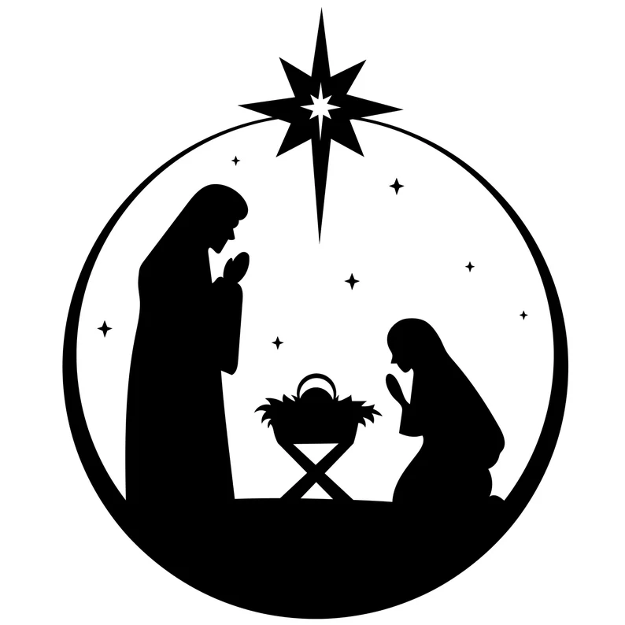

What Does the Holy Family Teach Us?

They Follow God’s Lead
The Scriptures paint the early life of the Holy Family as God calls them to a special mission. With the angel Gabriel, we greet Mary and learn of her calling to become the Mother of God. Our introduction to St. Joseph consists of him deciding to divorce Mary quietly, believing she brought shame and dishonor upon him and his family. But an angel invites Joseph to change his mind and take Mary into his home, to become the guardian of Mary and Jesus, the husband of Mary and foster-father of Jesus. In that home at Nazareth we meet a couple who shows an openness to allowing God to lead their life together. Mary surely had other plans for her life; as many believe, she took a vow of virginity at an early age, so becoming a physical mother was something she did not anticipate. Yet, she heard God’s invitation, and knew that His plans were better for her life; therefore, she gives her fiat — that is, her “yes” to God.
St. Joseph opens his heart to the messenger sent by God and takes Mary into his home. This would not be the first or last time that St. Joseph followed God’s lead in his life as he protected the Holy Family. After Jesus’ birth in Bethlehem, they follow the prompting of an angel to flee into Egypt for safety and wait there until another angelic message leads them back home. The Holy Family is a great example for families everywhere to always be open to whatever God’s will might be and to always be listening for God to speak. He might speak his will in prayer or through another person. By our own prayer and discernment, we too can follow God’s lead for our life.

A Teacher of Virtue
The home should be the principal place of catechesis. Unfortunately, many families today allow the Church to fill that role alone. The home of Nazareth, in addition to the local synagogue, would have been the place of instruction for the Christ Child. The Holy Family taught Jesus how to read, and at the start of his public ministry Jesus would read from the scroll and declare the passage to be fulfilled in their hearing (see Lk 4:21). Mary and Joseph would have taught the Christ Child how to pray, especially the Shema, and years later Jesus would teach his disciples how to pray with the Our Father. Joseph would have handed on his trade to his son, who later would die on the wood of a cross. Jesus had a great concern for the poor and the marginalized. In the home of Nazareth he learned generosity and kindness. The home of Nazareth reminds us that families have the responsibility of teaching their children the Faith and to model the virtues. Jesus had most excellent parents; Mary was without sin and Joseph is described as a just and prudent man. Parents today can learn from Joseph and Mary on how to teach their children.

HOLY FAMILY OF JESUS
The hidden life of Nazareth allows every person
to be in communion with Jesus
along the most ordinary paths of everyday life.
Nazareth is the school in which we begin to understand the life of Jesus, that is,
the school of the Gospel...
In the first place, may it teach us silence.
Oh! May an appreciation of this stupendous and indispensable atmosphere for the spirit return to us... May it teach us the way to live in the family.
Nazareth reminds us what the family is,
what communion of love is,
its austere and simple beauty,
its sacred and inviolable character…
Finally, let us learn a lesson of work.
Oh! House of Nazareth,
home of the “Carpenter’s Son”!
Here, we especially want to understand
how to praise the severe but redeeming law
of human labor...
We want to greet workers throughout the world
and show them their great model,
their Divine Brother.
(Saint Pope Paul VI, discourse of 5 January 1964)

